The Gospel of Luke
Chapters 1&2
Read Luke 1:5-25
Where does this story begin? ____________________________
What is unique about Elizabeth? __________________________
Other Characters who face this challenge:
Genesis 11:30 ³⁰ Now Sarai was barren; she had no child. (Sarai becomes Sarah with the promise of a child)
Genesis 25:21 ²¹ Isaac prayed to the LORD for his wife, because she was barren; and the LORD granted his prayer, and his wife Rebekah conceived.
Genesis 29:31 ³¹ When the LORD saw that Leah was unloved, he opened her womb; but Rachel was barren.
Judges 13:2 ² There was a certain man of Zorah, of the tribe of the Danites, whose name was Manoah. His wife was barren, having borne no children. (Mother of Samson).
1 Samuel 1:5 to Hannah he gave a double portion, because he loved her, though the LORD had closed her womb. (Mother of Samuel)
What must the child refrain from drinking? (v15) _____________
Why do you think this expectation is placed on John? _________________________________
- Both Samson and Samuel have this same restriction

What happens to Zechariah? _______________________ Why? _______________________
- Do you think Zechariah expected to be encountered by God?

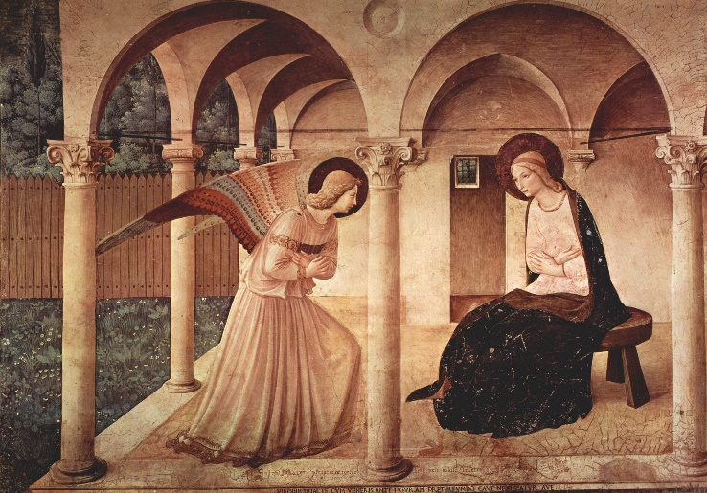
Read Luke 1:26-38
Mary is addressed as ‘favored one’. “But what a strange blessing. Today many assume that those whom God favors will enjoy the things we equate with a good life: social standing, wealth, and good health. Yet Mary, God’s favored one, was blessed with having a child out of wedlock who would later be executed as a criminal. Acceptability, prosperity, and comfort have never been the essence of God’s blessing. The story is so familiar that we let its familiarity mask its scandal.” (New Interpreters Bible Commentary, Vol. IX, pg 52.)
Annunciation, Fra Angelico ( c. 1437-1446)
Credit: Wikipedia
What are your impressions of Mary in this story? ___________________________________
Do all of your assumptions of Mary come from this Gospel? If not, where are they from? _________________________________________________________________________
In Luke 1:39-56 Mary visits her cousin Elizabeth for 3 months. When encountering Elizabeth, Mary sings a song that is known to us as “The Magnificat”. Mary’s song is curiously close to Hannah’s song in 1 Samuel 2:1-10.
In Luke 1:57-80, John the Baptist is born and Zechariah is able to speak again once the boy is named John. Zechariah then sings a hymn that is known as a “Benedictus” (blessing). This great blessing, the magnificat, and the birth of these children occurred in a time of great oppression when Herod the Great was a vassal King of Judea and the Roman Empire were a mighty controlling force. These are songs sung by faith and not by sight.
Read Luke 2:1-20
Luke places this story in the midst of a census. Why would Rome want an accurate census? ______________

According to Luke, who are the first people to visit Jesus? _______________________ Why might this be significant? ________________________
*Matthew doesn’t mention the shepherds but jumps immediately to the Magi (wise men).

Do you notice anything new about this story that you normally miss in the Christmas reading? ___________________________________________________________________________

In Luke 2:21-40 Jesus is taken to the temple in Jerusalem for circumcision and naming. Upon encountering the child the prophets Simeon and Anna bless Jesus. Simeon’s song is also known as the “Nunc dimittis” (Latin for now you dismiss). This passage is often used in funerals and occasionally sung as a closing to worship.
Read Luke 2:21-40 and note anything you find new or interesting.
______________________________________________________________________________________________________________________________________

Read Luke 2:41-52
This passage is the only one in scripture that speaks of Jesus childhood. Were there any elements that you found to be interesting or challenging?
__________________________________________________________________________________________________

One of the developmental tasks of childhood to Young Adulthood is discovering and affirming one’s identity. Jesus seems to express his identity here but not in connection to his hometown, his parents, or his sense of vocation. Instead, Jesus focuses on his relationship with God. This is a unique connection, that Jesus has recognition of his relationship to God prior to baptism. The other gospels locate Jesus’ understanding of his relationship to God in his baptism.

What questions do you have for next time?

