Ezekiel 1:1 – 3:27

Read Ezekiel 1:1-28
What do you notice about this imagery?
What is Ezekiel trying to convey?
Also Read: Exodus 25:10-22, Isaiah 6:1-12, 1Kings 22:19
Ezekiel’s vision is influenced by Israel’s Ark of the covenant and temple cherubim traditions. In Exodus 25:10-22, God gives detailed instructions for creating an ark flanked on each side by a golden cherub.
Exodus 25:20-22 ²⁰ The cherubim shall spread out their wings above, overshadowing the mercy seat with their wings. They shall face one to another; the faces of the cherubim shall be turned toward the mercy seat. ²¹ You shall put the mercy seat on the top of the ark; and in the ark you shall put the covenant that I shall give you. ²² There I will meet with you, and from above the mercy seat, from between the two cherubim that are on the ark of the covenant, I will deliver to you all my commands for the Israelites.
Isaiah 6:1-2 ^{NRS} Isaiah 6:1 ¶ In the year that King Uzziah died, I saw the Lord sitting on a throne, high and lofty; and the hem of his robe filled the temple. ² Seraphs were in attendance above him; each had six wings: with two they covered their faces, and with two they covered their feet, and with two they flew.
1 Kings 22:19 ¹⁹ Then Micaiah said, "Therefore hear the word of the LORD: I saw the LORD sitting on his throne, with all the host of heaven standing beside him to the right and to the left of him.
The Throne of God?
In 1 Kings 8:1-12 cherubim is not the creatures on the ark’s cover but two gold covered statues that stood at the Temple’s Holy of holies and beneath whose inner wings the ark was placed. These Cherubim are huge – 10 cubits high with a 10 cubit wingspan – 1 cubit = approx. 1.5 feet.

1 Kings 8:6-7 ⁶ Then the priests brought the ark of the covenant of the LORD to its place, in the inner sanctuary of the house, in the most holy place, underneath the wings of the cherubim. ⁷ For the cherubim spread out their wings over the place of the ark, so that the cherubim made a covering above the ark and its poles.

What do you make of the various beasts?

Book of Revelation also picks up some of this imagery:
^{NRS} Revelation 4:7 the first living creature like a lion, the second living creature like an ox, the third living creature with a face like a human face, and the fourth living creature like a flying eagle.

Other Early Christian authors saw these images as signs of the Gospel writers:
Early Christian Author | Human/Angel | Lion | Ox | Eagle
St. Irenaeus of Lyons 125ce | Matthew | John | Luke | Mark
St. Augustine of Hippo 345ce | Mark | Matthew | Luke | John
Pseudo-Athanasius 375ce | Matthew | Luke | Mark | John
St. Jerome 425ce | Matthew | Mark | Luke | John

Some images that try to convey this scene:

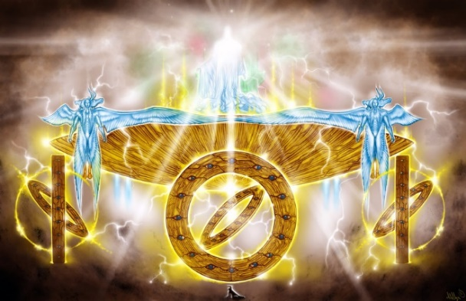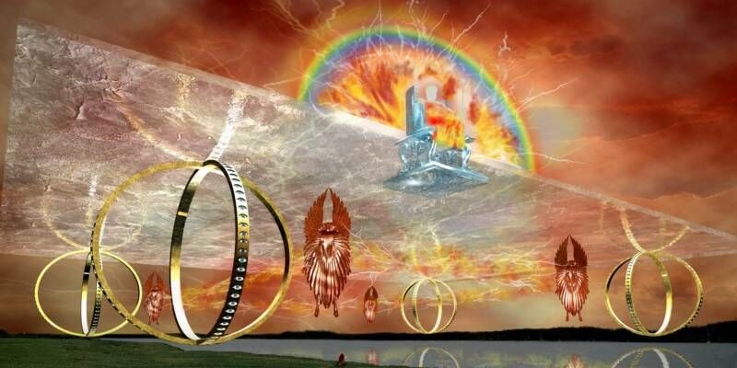
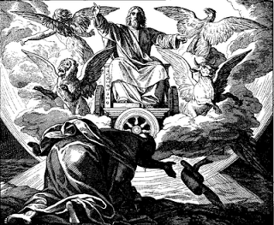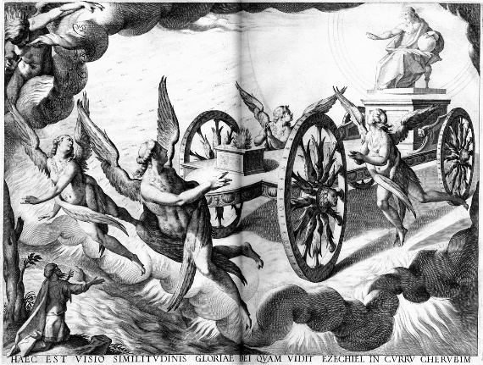

Read Ezekiel 2:1 – 3:15
How does this prophet receive his instruction/calling to preach?
Go back to Isaiah 6 – how is this commissioning different?
What does God think of this people?
In 3:8 – why should Ezekiel not be afraid?
What is Ezekiel’s response to all of this?

Read Ezekiel 3:16-28

Read this Analysis from Enterthebible.org
Ezekiel's role is compared to that of a watchman or lookout on the city walls. As the enemy approaches, the watchman must give the warning trumpet call. For a military lookout, failure of duty could result in execution. Ezekiel must prophesy God's word of judgment, even if the wicked do not listen or repent. The prophet must warn the righteous and the wicked alike in order to fulfill his obligation to his Lord; otherwise "their blood I will require at your hand" (3:18b), that is, God will hold Ezekiel responsible for their deaths. See also 33:1-9.

What do these passages convey to you about God?

What does it mean for God to say NO?

