1 Kings 1-11
October 27, 2016

Solomon becomes King: Read and discuss 1 Kings 1:1-14, 28-37
Notes:
Pay attention to Abishag the Shunammite – we will see her later.
One would expect Adonijah to succeed his father due to several factors (vv. 5-8):
• Since Amnon (2 Samuel 13:28-29), Chileab (3:2-5), and Absalom (18:14-15) were dead or missing, Adonijah is the eldest surviving son.
• David had not questioned his "very handsome" (like his father?) son's claim to the throne.
• Adonijah enjoyed military (General Joab) and cultic (Zadok the priest) support.
The question in this dynasty is whether the next ruler be the eldest child or the chosen child? Remember that David was not the son of Saul.
Solomon Solidifies His Kingdom: Read and discuss 1 Kings 2:5-9, 13-25
Horrific as the bloodbath Solomon employed to solidify his power seems to us, there were good reasons for his actions, at least by ancient standards. The exile of Abiathar was due to a curse placed upon his priestly family (1 Samuel 2:27-36). Similarly, the execution of General Joab was required to purify the dynasty of the blood guilt incurred by Joab's murder of Abner and Amasa (2 Samuel 3:26-30; 20:8-10). The execution of his brother, Adonijah, was in response to Adonijah's request of Abishag, tantamount to sharing royal power with Solomon.
What are the methods used for solidifying Solomon’s kingdom?
Solomon’s prayer for Wisdom:
Summary: We learn that Solomon marries the daughter of a pharaoh of Egypt. He has now reached a level of status to be on the same stage as the other great leaders of the world. Solomon honors God through sacrifices at one of the “high places” and while there he has a dream. In the dream, God says “Ask what I should give you.” Solomon humbly admits that he doesn’t know what he is doing as king and asks God for “an understanding mind to govern your people, able to discern between good and evil?” God is pleased and tells Solomon he will grant great wisdom and all the things he didn’t ask for (a long life, riches, and honor). Solomon wakes up. Discuss:
Read 1 Kings 3:16-28 to see Solomon’s wisdom in action (See also 4:32)
Solomon and the Temple: Read and discuss: 1 Kings 5:1-6, 13-18 – discuss the temple.
What do you notice about the temple? How was it built?
Chapters 6 & 7 share all of the details of the temple and Solomon’s Palace. Solomon took 7 years to build the temple and 13 years to build his palace. Each of these buildings were very elaborate and ornate.
Summary of 1 Kings 8:
Solomon dedicates the temple of God. First he has the priests bring the Ark of the Covenant into the temple. Then Solomon gives a speech, prays a long prayer which is more of an announcement that details some of the theology of the temple. Finally Solomon blesses the assembly and sacrifices many thousands of animals over 7 days.
Read and Discuss 1 Kings 9:1-9
What are God’s commands for Solomon so that he might remain successful?

Solomon’s Greatness, Errors, and Downfall:
Read and Discuss 1 Kings 10:23-25, 11:1-13 – also note God’s action in v. 14.

Read and Discuss 11:26-32 & 40-43
Who is the “servant”?
Who is Solomon’s Son that is destined for the throne?
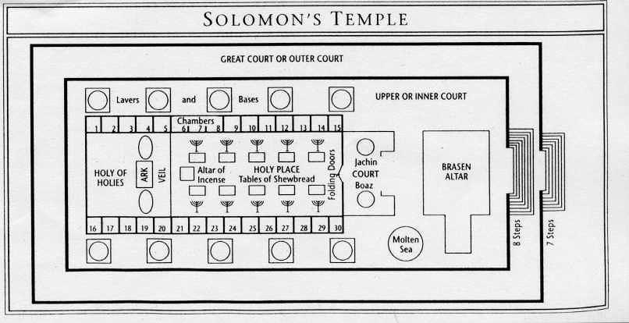
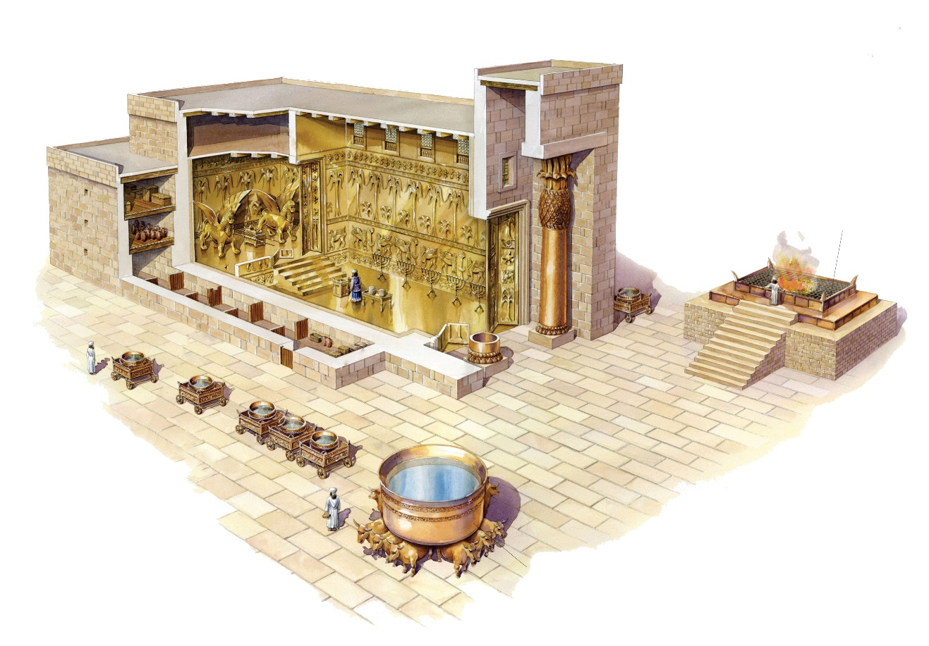

www.enterthebible.org – Dr. Mark Throntviet

