1 Corinthians 1-7
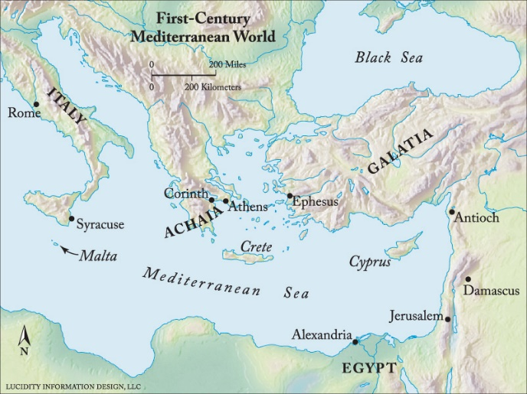
Background: (enterthebible.org)
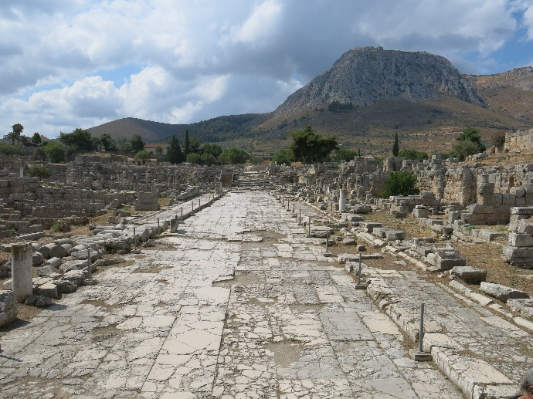
Sometime in the 40s, Paul founded a church, or more likely several smaller house churches, in the port city of Corinth. The city itself was a diversely populated urban center, and that diversity may have been mirrored in the community of Gentile believers Paul drew together.
After living in Corinth for some time, Paul went on to other work. Then, in response to a letter from the Corinthians and a report from "Chloe's people" (1 Corinthians 1:11) that the church was experiencing division, Paul wrote his first letter to the Corinthians. He was living in Ephesus at the time (see 1 Corinthians 16:8-9), and he anticipated visiting Corinth soon after the letter arrived.
The report and letter Paul received led him to conclude that the Corinthians were disagreeing with each other about the quality of leadership Paul and other apostles had offered, about the implications of their new spiritual existence for decidedly physical activities like eating and being involved in sexual relationships, about whether their experience of being in Christ made them at all responsible to other brothers and sisters in Christ, and similar issues.

How do we read it?
First Corinthians is part of an ongoing correspondence between Paul and the church in Corinth. We can only guess-in more or less educated ways-at what exactly happened in Corinth and what sort of relationship Paul had over time with believers there. We read the letter much as we might listen to one side of someone else's telephone call. That is, we are realistic about gaps in our understanding and careful in attempts to reconstruct the other half of the conversation. This level of humility is especially important when reading parts of the letter that are alien to our sensibilities or contrary to the understanding of the gospel we have as a result of engaging the whole of the biblical witness.

Theological Themes:
• The body. Some Corinthians thought that the body was of no consequence since they were spiritually joined to Christ. In their spiritual state, the state and possible pollution of the body was no longer a concern: they could eat meat that had been offered to idols (see 1 Corinthians 8-10), engage in sex with prostitutes (see 1 Corinthians 6:12-20), or eschew sex altogether (see 1 Corinthians 7:1).
Paul does not concede any dichotomy between body and spirit. In fact, he uses the spiritual connection believers have to Christ as a reason to urge his readers to shun fornication and instead, "glorify God in your body" (1 Corinthians 6:20). Furthermore, he argues for a general resurrection of the dead that will result in imperishable bodies being raised up to new life in Christ. Paul nowhere disparages the human body in favor of a disembodied spirituality, and he urges the Corinthians not to do so either.

• Body of Christ. Many of the issues dealt with in 1 Corinthians concern physical human bodies (for example, sexual relationships, prophesying with one's head covered or uncovered, eating or going hungry at the Lord's Supper, and the bodily resurrection of the dead). Paul's way of addressing all of these issues is to move from a focus on individual human bodies to the implications of each person's actions for the corporate body of believers. He identifies those to whom he writes as the body of Christ, and writes, "For just as the body is one and has many members, and all the members of the body, though many, are one body, so it is with Christ" (1 Corinthians 12:12).
• Christian community. The Corinthians had many ways of distinguishing themselves from one another and ranking themselves over against each other. Knowledge, wisdom, strength, spiritual gifts, loyalty to particular leaders: the people to whom Paul wrote had converted all of these things into means by which they sought status for themselves and assigned status to others. The letter of 1 Corinthians is a sustained argument against such attempts at ranking one another. The letter offers a vision of Christian community at the center of which is the Spirit embodied by Christ, the crucified one. This community is characterized by God's choice of "what is low and despised in the world" (1 Corinthians 1:28) and by love that "bears all things, believes all things, hopes all things, endures all things" (1 Corinthians 13:7).

• Day of the Lord. Along with many other Jews of his time, Paul believed that God was on the verge of a cosmic intervention by which all would be judged and the righteous would be saved from God's wrath. The general resurrection of the dead had long been thought to be a feature of such a Day of the Lord, and Paul concluded that Christ's resurrection signaled that the Day of the Lord was near. In several of his letters, Paul speaks of an imminent day of divine judgment, and three times in 1 Corinthians (1:8, 3:13, and 5:5), he refers to the approaching "day" or "day of the Lord." At one point, Paul refers to himself and the Corinthians as those upon "whom the ends of the ages have come" (1 Corinthians 10:11). Because of his conviction that Christ is about to return, Paul's words to the Corinthians have both an urgency and an interim quality about them.
AUTHOR: Mary Hinkle Shore, Associate Professor of New Testament

Outline: (J.Paul Sampley, New Interpreters Bible Commentary, Volume 10, pg 792)
1 Corinthians 1:1-4:21, Opening and Appeal
- 1:1-9 Letter Opening
- 1:10-4:21, Paul’s Contextualizing of the Letter
  - 1:10-17, The Opening Appeal
  - 1:18-25, Christ, True Power, True Wisdom
  - 1:26-31, Paul’s Application to the Auditors
  - 2:1-5, Perspective-Keeping via Paul’s Exemplary Pattern from the Founding Days
  - 2:6-16, Two Wisdoms, Two Spirits, Two Representative People
  - 3:1-4, Not Spiritual People, Babies, Merely Human
  - 3:5-9, Apollos and Paul: Models
  - 3:10-15, The Foundation and Each Person’s Work
  - 3:16-17, You are God’s Temple
  - 3:18-23, Self-Awareness and Proper Perspective
  - 4:1-5, The Apostles, But especially Paul, As Exemplary Once More
  - 4:6-7, The Explicit Key to Paul’s Strategy in Chapters 1-4
  - 4:8-13, The Grand Charade Seen with Evangelical Irony
  - 4:14-21, Paul Embraces and Warns his Beloved Children
1 Corinthians 5:1-6:20, Community Definition as seen in two related instances
- 5:1-13, The Stain within: A threat to the holiness appropriate to the Temple of the Holy Spirit
- 6:1-11, Wrongfully crossing the border in the other direction: Taking Community Matters out into the World
- 6:12-20, Summing Up and Looking Ahead
1 Corinthians 7:1-40, Paul’s response to questions about relations in sociosexual groups
- 7:1-7, Husbands and Wives
- 7:8-9, Widowers and Widows
- 7:10-11, Married Believed and Divorce
- 7:12-16, Marriage Between Believers and Unbelievers
- 7:17-24, Indifferent Matters: Jew, Greek, Slave, Free
- 7:25-28, Counsel for Unmarried: Paul’s Own Maxim
- 7:29-35, A digression regarding life lived eschatologically
- 7:36-38, Betrothed Unmarried and the Idealized Responder
- 7:39-40, Divorce, Widowhood, and Remarriage

Bible Study:
In the opening verses Paul thanks God for the Corinthian Believers.
“Because believers are totally dependent on God’s transforming grace for their new life in Christ, their basic response must be one of thankfulness to God; Paul expects thankfulness to God from all persons, and here he himself models it.”

Overview of the section:
“Roughly one-fourth of the letter, 1:10-4:21, sets the context, the background for Paul’s subsequent treatment of particular problems in Corinth, identifies the Corinthian tendency toward divisiveness, and reminds the Corinthians of his exemplary and paternal caring for them. This important passage rehearses Paul’s relationship to the Corinthians and theirs to the gospel.”

Read 1 Corinthians 1:10-17
Discuss: What are the divisions you hear in this passage?
To whom do you belong? (Martin Luther, John Wesley, Paul, yourself?)
Who claimed you in baptism?

Read 1 Corinthians 1:18 – 2:5
Discuss: but we proclaim Christ crucified… what is the relationship between wisdom of the world and your faith?
What does it mean that God chose what is foolish to shame the wise?
Are the ‘foolish’ welcome in our church? In our community?
What does ‘proper’ boasting look like?
What does Paul think of his preaching?

In 1 Cor. 2:6-16, Paul shares that he sometimes does speak with wise words among the ‘mature’ in faith. In all discernment our understanding comes from the Spirit not from ourselves. For this reason the unspiritual cannot understand the spiritual matters Paul discusses.

Read 1 Corinthians 3:1-9
Discuss: What does it look like to be spiritually mature?
What is the relationship between Paul and Apollos?

1 Cor. 3:10-15 discusses foundations: “What will be weighed on judgment day is the work “of each one” (3:13). This is consistent with what Paul says in Romans 2:6 and with his later statement to these same Corinthians: “It is necessary for all of us to appear before the judgment seat of Christ so that each may receive according to what he has done in the body, whether good or bad”(2 Cor. 5:10). What one does, how one builds on the foundation of Christ, how one lives up to one’s calling, these are the maters on which the judgment will focus. Significantly, one’s faith will not be judged; why should God judge what is, after all, a gift from God, a working of the Spirit (1 Cor.12:9)? Paul’s primary subject matter in all his letters is understandably the proper comportment of the life of faith because the last judgement will focus on how one has lived the life God has given, on how one has walked in God’s grace.”
Read 1 Corinthians 3:16 – 4:5
Discuss: What the temple of the Spirit? How does this work?
Who is judge? Why does this matter?
Chapters 5 & 6 address complaints that he has heard about sexual immorality and about the believers settling disputes in the court system rather than in the church.
1 Corinthians 5:1 ^{NRS} 1 Corinthians 5:1 ¶ It is actually reported that there is sexual immorality among you,
The HOLY SPIRIT is to be IN/AMONG them – what has taken the Spirit’s place?
Read 1 Corinthians 6:12-20
Discuss: You were bought for a price, therefore glorify God in your body.
What does this mean for your relationship with God?
What does this mean for how you should live in the world?
“The body is not for porneia but for the Lord and the Lord for the body” (6:13) . Without using the term this is holiness talk. To be set apart for something or for someone is the root meaning of holiness. Today we tend to think of “having a body”; we might even find ourselves talking about “our bodies” as if they were another one of our possessions. For Paul, humans do not have bodies; they are bodies.
Discuss bodies:

Read 1 Corinthians 7: 1-16

Discuss sexuality and the issues Paul raises:
How are these unique to Paul?
How can they speak to us?

Read 1 Corinthians 7: 17-40

How would Paul’s advice possibly be different if he felt that Christ’s return was a long way off?
What does this segment speak to you?

(J.Paul Sampley, New Interpreters Bible Commentary, Volume 10, pg 800)
Ibid, pg 801
Ibid, pg 829
(J.Paul Sampley, New Interpreters Bible Commentary, Volume 10, pg 800)

