Introduction to the Apostle Paul
Born: Saul - 5 BCE – 5 CE Died: 62CE – 68CE
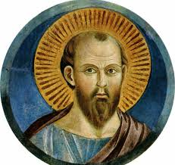
From: Tarsus (Roman Citizen)
Religion: Jewish – from the tribe of Benjamin
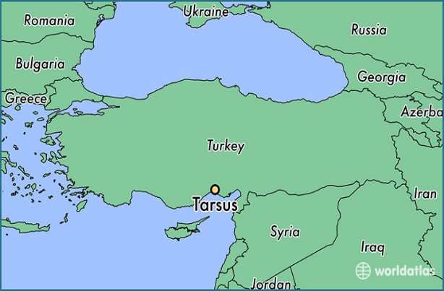
Work: Pharisee – Saul/Paul was from a religious family and with his education he became a leader among a political/social group known as the Pharisees. The Pharisees were opposed to the Hellenization of Hebrew culture, had a strong emphasis of upholding the Mosaic law. Compared to the Sadducees who only followed the Greek version of the Torah (with Greek philosophical updates) the Pharisees used the ancient Hebrew Torah with the prophets, writings, and oral traditions, including belief in the resurrection of the dead.
As a Pharisee Paul was an active persecutor of the Early Church. Taking a role in persecuting and even killing those who confessed Jesus as God, which was seen as blasphemy.
Tent maker – Acts 18 reveals that in his initial Christian Ministry Paul worked as a tent maker.
Missionary – Later ministry was conducted primarily through offerings and the kindness of communities that provided for Paul and his colleagues.
Education: Acts 22:3 tells us he studied under Gamaliel one of the most noted Rabbis in history. Paul attended the Hillel School which was noted for giving its students a balanced education. Paul likely had broad exposure to classical literature, philosophy, and ethics. In his letters, Paul often drew upon his knowledge of Stoic Philosophy.
Stoicism is predominantly a philosophy of personal ethics which is informed by its system of logic and its views on the natural world. According to its teachings, as social beings, the path to happiness for humans is found in accepting this moment as it presents itself, by not allowing ourselves to be controlled by our desire for pleasure or our fear of pain, by using our minds to understand the world around us and to do our part in nature's plan, and by working together and treating others in a fair and just manner. (https://en.wikipedia.org/wiki/Stoicism)
Conversion: Read Acts Chapter 9:1-22
Early Ministry: In the letter to the Galatians Paul describes going to Arabia (some speculate to Mount Sainai to meditate) then returning to Damascus to live. Paul then worked as a tent maker for 3 years ministering locally before going to Jerusalem to meet the other Apostles and receive a blessing/commissioning of his ministry to the Gentiles. On his first missionary journey, Paul is sent as an apprentice to a more established Christian, Barnabas.

Timeline of Paul’s Christian Ministry:
Year Event
33 Paul’s conversion/call near Damascus (Gal 1:17, Acts 9:1-22 [22:6-21; 26:12-18])
35 1st Journey to Jerusalem (Gal 1:18-20; Acts 9:26-29)
47-48 Mission from Antioch to Asia (Phil 4:15; Acts 13-14) – 1st Missionary Journey
48 2nd Journey to Jerusalem: the Jerusalem Council (Gal 2:1-10; Acts 15:1-12)
49 Macedonian mission from Galatia to Athens (1 Cor. 16:1, 2 Cor. 11:9, Gal 4:13, 1 Thess. 2:2, 3:1; Phil 4:15-16; Acts 16:6)
49-52 Claudius’s Decree (Acts 18:2); Corinthian Mission (2 Cor. 1:19; 11:7-9; 1 Thess. 3:6; Acts 18:11)
50 Paul writes 1-2 Thessalonians
53-56 Ephesian Mission (1 Cor. 16:1-8, Acts 19)
53 Paul Writes Galatians
54 Paul writes 1 Corinthians
55 Paul writes Philippians and Philemon
55-56 Paul writes 2 Corinthians
56 Paul’s Painful return to Corinth (2 Cor. 13:2)
57 3rd Visit to Corinth (2 Cor. 13:1, Acts 20:1-3)
57 Paul writes Romans
57 3rd Journey to Jerusalem (Rom. 15:22-27; Acts 21:15- 23:30)
57-59 Imprisonment and legal “trial” in Caesarea (Acts 23:31-26:21)
58 Paul writes Colossians (And Ephesians?)
60-62 Arrival and imprisonment in Rome (Acts 28:15-31)
62-? Paul’s Mission in Spain (Rom 15:22-24); Paul writes to Timothy and Titus?

Death: The New Testament does not tell us about Paul’s death. Many theories were proposed in the early church. Some speculate that he died in Spain. Early church leaders (200+ years after Paul) said that he died under Emperor Nero sometime between 64 and 68 CE.
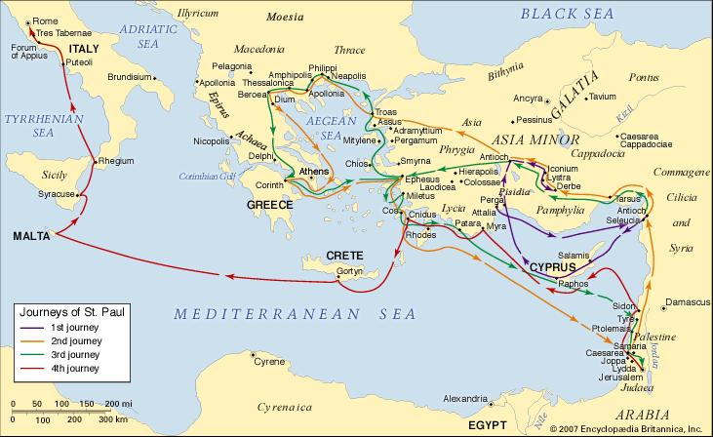

New Interpreters Bible Commentary, Volume 10, Abingdon Press, 2002 pg 373

