Galatians – Intro & Chapters 1-2
Summary – Notes from www.enterthebible.org
Paul writes to the Galatian Christians out of deep concern that they are forsaking the gospel that he has preached and are listening instead to the message of certain Jewish Christian evangelists who are arguing that Gentile Christians must be circumcised according to Jewish law. Paul insists that people are justified by faith in Christ rather than by keeping the requirements of Torah. By faith, they participate in the death and resurrection of Christ and now live as God's children and heirs of God's promises. By the Spirit's leading, this life of faith is no longer marked by sinful works of the flesh but bears fruit in freedom that serves the neighbor through love.
So What?
Galatians achieves its goal when those who read it are enabled to hear the good news that God has called each one of them by the grace of Christ. All are justified and made right with God by faith in Christ and not by doing the works of the law. That we are children of God according to God's promise in Christ is not just wishful thinking; it is the promise that in the cross of Christ we are really a new creation--freed, transformed, and empowered by the Spirit's leading for loving service of the neighbor.

When Was It Written?
While all the so-called genuine letters of Paul were probably written between 51 and 57 C.E., the precise dating of Galatians within that span depends largely on the locations of the churches to whom the apostle wrote. The more satisfactory theory that these recipients were in north Galatia, together with the fact that a number of the letter's central themes are worked out in more depth in the Letter to the Romans, suggests a date closer to the writing of Romans, perhaps 55-56 C.E.
Background:
To gather from his letter, Paul had founded the Galatian churches somewhat by accident, when illness overtook him during travels through Asia Minor, and the Galatians welcomed him and nursed him back to health (4:13-16). They also welcomed with enthusiasm his message that in the cross of Christ they were liberated from the demonic powers of this world and became adopted children of God. Sometime after Paul's departure, other preachers apparently arrived with a different message. They argued that Paul's version of the gospel was deficient, asserting that according to the Jewish Scriptures the promises of God belong to the children of Abraham and that one becomes a child of Abraham through circumcision. Notice of this controversy within the Galatian churches came to Paul, and he was compelled to write with some urgency and passion (1:6; 4:20; 5:12) to reassert the integrity of his commission as an apostle and of the gospel that he preached. It is faith in Christ that makes one right with God, and it is the promise of God in the cross of Christ and not the doing of certain works, such as circumcision, that makes one a child of God with Abraham. Those who assert the necessity of circumcision have "severed" themselves from the grace of Christ.
The letter's address to "the churches of Galatia" (1:2) implies a number of communities, but interpreters of the letter have disagreed over these churches' location. According to the "south Galatia" theory, Paul refers to a territory reorganized by the Romans as a province including the original kingdom of the Galatians to the north. This theory assumes that these congregations were founded during Paul's so-called "first missionary journey" (compare Acts 13-14) and has the advantage of harmonizing the letter with the Acts account. According to a competing "north Galatia" theory, Paul writes to churches located in the original territory of Galatia. Those favoring this theory note other discrepancies between the narrative of Acts and Paul's own letters and point to the fact that Paul's use of the ethnic term "Galatians" for these people would fit better with a more traditional regional identity. The majority of scholars support this north Galatian theory.
Opinions about the location of these churches also have implications for the dating of the letter. Those who favor the south Galatia theory tend to date it early among Paul's surviving writings, assuming that the churches' founding is to be associated with Paul's first missionary journey. Those, however, who support the north Galatia theory assume that the founding is associated with another journey through Asia Minor and accordingly date the letter later, toward the middle of Paul's letters and thus around 55 C.E.
AUTHOR: James Boyce, Professor of New Testament and Greek
Outline: (New Interpreters Bible Commentary XI)

Galatians 1:1-10, The Letter Opening

1:1-5, Salutation

1:6-10, Rebuke and Curse

Galatians 1:11-2:21, A Narrative Defense of Paul’s Gospel

1:11-12, Thesis Statement: The Divine Origin of Paul’s Gospel

1:13-24, Paul’s Apostolic Call and Independence from Jerusalem

2:1-10, Paul’s Meeting with the Jerusalem Leaders

2:11-21, Two Tables or One? Confrontation at Antioch

Paul’s Rebuke of Cephas

Jews and Gentiles alike are Rectified through Christ’s Death

Galatians 3:1-5:1, Counterarguments Against the Rival Missionaries

3:1-5, The Experience of the Spirit

3:6-29, The Promise to Abraham

The Blessing of Abraham included Gentiles

Christ’s death Liberates Israel from the Law’s Curse

The Covenant Promise Predated the Law

The Law as Temporary Custodian

In Christ We Are Abraham’s Seed

4:1-11, The Fullness of Time Has Come

We are heirs and children of God

No turning back

4:12-20, An Appeal to Restore a Ruptured Relationship

4:21-5:1, An allegory of Slavery and Freedom

Galatians 5:2-6:10, Pastoral Counsel to the Galatians

5:2-12, A Call to Reject Circumcision

5:13-15, Freedom for Love

5:16-26, The Works of the Flesh and the Fruit of the Spirit

6:1-10, Life together in the Church

Galatians 6:11-18, Postscript: The Cross and New Creation

Bible Study:
Read Galatians 1:1-10
Imagine a dear friend sent you a letter that began with this type of rebuke. How would you receive this news?

What questions do you have about Paul’s challenge to the Galatians?

Read Galatians 1:11-2:10
Paul tells some of his story in this passage. Paul used to be very zealous for the “law”. What connection is he making between zeal and persecution?

Is zeal and persecution limited to Judaism?

What is God’s response to violence (revealed in Jesus)?

How radically was Paul changed by the Gospel? Does life change still happen today?

Look at Paul’s relationship with the authority figures of the church in his day? What is Paul’s most important priority?

Read Galatians 2:11-21
Remember that Cephas is another name for Simon “Peter” “on this rock I will build my church”. Cephas (Rock,Stone) comes from Aramaic and was adopted into Greek then Latin. Petros (Peter) is the original Greek word for Rock. They seem to be used interchangeably.

What is Cephas doing at Antioch?

There is no Jewish law that prohibits eating with gentiles. What would be the effect of Peter withdrawing from the Gentile communities? Why is Paul so upset?

What point is Paul trying to convey in 2:15-21?

dia. pi,stewj VIhsou/ Cristou/
This Greek phrase means either “through faith in Jesus Christ” or “through the faithfulness of Jesus Christ”.

By which are we saved? Can it be both?

Introductory Issues:
• Circumcision. The presenting occasion of Galatians is the issue of circumcision (see 2:3, 7, 8, 9, 12; 5:2, 3, 6, 11; 6:12, 13, 15). Although the identity of Paul's opponents and the precise reasons for their opposition are debated, it is clear that some in the Galatian community were arguing that the promises of God belong to the children of Abraham, and that one becomes a child of Abraham through circumcision. Their pressing for the practice of circumcision (see 5:3, 11; 6:12-13), in addition to keeping other parts of the law (3:2; 4:21; 5:4, 18), thus challenged Paul's gospel message and his authority as an apostle (1:1). Paul's response is to assert again the heart of the gospel: just as was the case for Abraham (3:18), being a child of God is grounded in hearing the promise. God has acted in the death and resurrection of Christ to free all people and to claim them as children along with the children of Abraham. To hold to circumcision is to deny the cross of Christ and to reject the new creation that lives by the guidance of the Spirit (5:5-6; 6:15).
• Doing the law or hearing the promise. To judge from Paul's remarks, the key argument among the Galatians was over the question of how one becomes a child of God and is included among the children of Abraham. Paul lays out two options for the Galatians. It is either a matter of doing something or it is a matter of hearing something. In 2:16, he asserts from his own experience that one is justified not by "doing the works of the law" but "by faith in Christ." In 3:2-5, he expands this by inviting the Galatians to confirm by their own experience that life in the Spirit is not a matter of "doing the works of the law" but "believing what you heard." In carefully orchestrated arguments in chapters 3 and 4, Paul asserts repeatedly that, just as was the case for Abraham, so for those who belong to Christ: being a child of God is a matter of "hearing the promise" through faith (see 3:14, 16, 17, 18, 29; 4:23) and not of "doing the law."
• The faith of Christ. The NRSV text of Galatians 2:16 and its translation notes reveal differences among readers about how best to express Paul's key understanding of faith and justification in relation to Jesus Christ. Twice Paul says we are "justified by" ("justified through" is also possible) "the faith of Christ" (a literal rendering of the Greek phrase pistis Christou). The NRSV translates this as "faith in Jesus Christ" but offers the alternative "faith of Jesus Christ" in a footnote. It is clear that for Paul the good news of the gospel begins and is anchored in God's call by grace through the cross of Christ Jesus (1:6, 15) and continues in the life the Christian now lives by faith (2:20). The issue of interpretation hinges here on how best to express the difference that Paul describes between being justified not "by works of the law" but "by faith." Should one describe this crucial relationship with the words faith in or toward Christ, that is, with Christ as the end or object of faith? Or is it better to speak of this relationship as a matter of Christ's being faithful, or of "Christ's faithfulness," that is, to call attention rather to God in Christ as the author or agent of justification?
• Law and gospel. Paul argues in Galatians for the "truth of the gospel," that all people, Gentile and Jew alike, are justified or made right and called to be God's children by God's grace through faith in Jesus Christ and not by doing the works demanded by the law (2:16). Such persons have died to the law and now live by faith by virtue of Christ's indwelling life. To continue to hold on to the law as having some place in justification, Paul says, is to pervert the gospel and make Christ's death on the cross count for nothing (2:19-21). The natural question, then, is why God gave the law. Paul answers that the purpose of the law was to hold the transgressions of sin in check until the one heir promised to faith, Jesus Christ, should come and be given to those who believe. So the law was a "guardian" or "custodian" set in place until the coming of Christ. Those who have been baptized into the cross of Christ are really a new creation who no longer need the law by which to live. By the good news of God's grace they have been set free and empowered to live for the neighbor through a "faith that is active in love" and so already fulfill in their heart and action all that the law demands (5:14).
• Paul's autobiography in Galatians 1 and 2. As part of the defense of the gospel that he preached, Paul gives an autobiographical account of his conversion, call, and early missionary activity (1:10-2:14). He roots his apostleship to the Gentiles in an original call of God and in a conversion experience through a direct revelation of Christ Jesus. The timeline implied by his reference to two Jerusalem visits, one three years after his call (1:18) and then again after fourteen years for a council at which his apostleship to the Gentiles receives approval (2:1-10), is not easy to square with the account of Paul's conversion and mission in the Acts of the Apostles (see Acts 9:1-19; 23-28). While here in Galatians Paul is concerned to underscore his independence from the Jerusalem authorities, Acts is much more interested in his conversion experience on the road to Damascus, relating it at least three times (9:1-19; 22:1-15; 26:4-20). Despite a roughly consistent outline, it is also difficult to fit Paul's narrative in Galatians 1-2 to the schema of three neatly defined missionary journeys in Acts (see Acts 13:3-14:28; 15:40-18:22; 18:23-21:17).
AUTHOR: James Boyce, Professor of New Testament and Greek
Theological Themes:
• Faith active in love. The problem with concern for keeping the law is that it shortchanges the care that is due the neighbor. Those who insist on circumcision prevent hearing the freeing message of the gospel of God's grace that releases people for a "faith working through love" (5:6). Such active love of the neighbor is the true fulfillment of what the law imagines.
• Freedom. The gospel of justification by God's grace means freedom (5:1). But the central significance of this freedom in Christ is that freedom is not an end in itself. Those who are set free by the good news of the gospel are in turn enabled "through love [to] become slaves to one another" (5:13).
• Fruit of the Spirit. The promise of the gospel is that those who belong to Christ are energized and empowered in a new life that is guided by the Spirit. Such new life no longer lives under the law and by the desires of the flesh, but instead produces a singular fruit of the Spirit that blossoms in community expressions of "love, joy, peace, patience, kindness, generosity, faithfulness, gentleness, and self-control" (5:22-23).
• Gospel. Paul's opening address announces the good news (gospel) that God raised Jesus Christ from the dead and that by God's grace Christ gave himself to set us free from sin and the power of the present evil age. Fully thirteen times in the opening two chapters Paul makes reference to this good news by which God has called his readers and him to new life in Christ (1:6, 15). He pleads that the Galatians not risk losing this grace-filled gift by following the misleading and elusive promises of a deceitful "gospel."
• Justification. In 2:16, Paul for the first time substitutes the word to justify ("to be made right") for the word gospel. Clearly in this letter "justification" (used a total of thirteen times from 2:16 on) is Paul's synonym for the good news of the gospel. The good news of the gospel is that we are made right by God's grace through faith in Jesus Christ and not by works of the law.
• Life in Christ. The certain promise of the gospel is that through baptism the Christian is literally joined with Christ's death and resurrection. The old person is put to death with Christ (compare Romans 6:6) so that now God's children live a new life by virtue of the loving gift of God's Son, who lives in them.
• New creation. At the letter's conclusion Paul says, "Neither circumcision nor uncircumcision is anything; but a new creation is everything!" (6:15). The promise of the gospel is that those who have been baptized into Christ Jesus have been linked with his cross, death, and resurrection. Now "clothed with Christ," they live by virtue of Christ living in them (2:20).
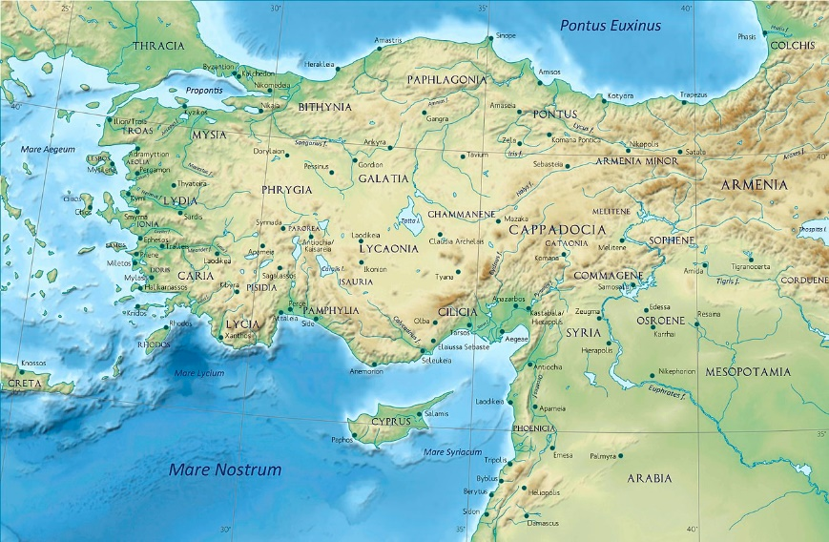
• Unity in Christ. "For all of you are one in Christ Jesus" (3:28). In language and vision that is almost unique in the New Testament, Paul asserts that, by virtue of their being common heirs of God's promise in Christ, God's children are united in a new relationship that transcends all traditional barriers of alienation or division. Unity in Christ brings with it the promise of a fundamentally changed social order.
AUTHOR: James Boyce, Professor of New Testament and Greek

Galatia was a region in the middle of modern day Turkey. It’s capital was Ankyna which is the capital of Turkey today (Ankara).
https://commons.wikimedia.org

