The Book of Esther

Introduction From Enterthebible.org

SUMMARY
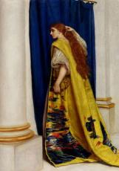
Ahasuerus, all powerful king of Persia, banishes his queen Vashti for failing to appear before him when bidden. The new chosen queen is Esther, cousin and adopted daughter of Mordecai, the Jew. Mordecai's bitter enemy at court is the wicked Haman, the king's right-hand man. Because Mordecai fails to bow before him, Haman plots not only Mordecai's death but also the extermination of all the Jews. Mordecai calls on Queen Esther to save her people. Esther heroically risks the king's wrath by appearing unbidden before him. She invites King Ahasuerus and Haman to two banquets where she persuades the king both to save her people and also to hang Haman on the very gallows he had constructed for Mordecai. The king's edict to kill the Jews is reversed, and the Jews instead get revenge on their would-be persecutors and celebrate, initiating the festival of Purim.

SO WHAT?
The book of Esther teaches indirectly rather than directly four lessons: (1) Maintaining community and religious identity in foreign territory is a tricky but terribly important task. (2) Through wisdom, wit, and courage, people can live productively in a foreign land, even when subject to the whims of a foreign power. (3) Even when God remains hidden, unnamed, and seemingly absent, as in the book of Esther, one can detect the presence of the divine in favorable coincidences and in the bravery of leaders who step up when needed. (4) All of this is taught through irony and humor, which provides the book's final lesson: laughter gives life.

WHO WROTE IT?
The book of Esther gives no real hint as to who wrote the book. It was possibly written by a Jew living in the Diaspora, perhaps in a foreign court, as a way of entertaining and inspiring his or her Jewish community and establishing the festival of Purim.

WHEN WAS IT WRITTEN?
The book of Esther describes events that purportedly took place during the reign of the Persian King Ahasuerus, probably a reference to Xerxes I (486-465 B.C.E) or possibly Artaxerxes I or II (465-358 B.C.E.). Given the language used, certain factual discrepancies, and the opening verse of the book that looks back in time, the book was probably written sometime between 400 and 150 B.C.E. This makes the book of Esther one of the latest writings of the Old Testament, close in time to two intertestamental books about women: Judith and Suzanna.
AUTHOR: Diane Jacobson, Professor of Old Testament

WHAT'S IT ABOUT?
The book of Esther tells the story celebrated at Purim of how Queen Esther and her cousin Mordecai saved the Jewish people from the plot of the wicked Haman, who was advisor to the Persian King Ahasuerus and who tried to have the Jews destroyed.
The book of Esther invites the reader into the world of the powerful and wealthy Persian royal court. The Persians came into power throughout the ancient world under Cyrus the Great (560-530 B.C.E.) and continued their dominance until the conquest of the Greeks under Alexander the Great in 333 B.C.E. Under Persia, the Jews were subject to yet another powerful empire, as they had been subject to the earlier empires of Egypt, Assyria, and Babylon prior to the Persians, and as they will soon be subject to the later empires of Greece and then Rome. The Persian court as described in Esther is rich and powerful beyond imagining, and, as with all empires, the people must deal with palace intrigues, with the whims of power and foreign law, and with the inevitable scapegoating of foreign peoples. The book is written with irony and humor for the purpose of encouraging the Jewish people in such a situation. The Jews are now a people in Diaspora--that is, scattered throughout the ancient world--and Esther provides inspiration (and a bit of fun) as they try to discern how to live in a foreign land. They must balance the call to assimilate and to serve the capital city of Susa, where they now live, with the continued need to maintain their own separate identity as a people. And in all of this, the book of Esther helps them to discern the presence of God in a time and place where God seems quite absent.

HOW DO I READ IT?
The book of Esther is best read as a satiric melodrama to be recited or dramatized each year during the Jewish festival of Purim, which this book both establishes and celebrates. The story is filled with entertaining reversals, ironies, parodies of the great Persian court, and exaggerations that invite the reader to cheer on the heroes Esther and Mordecai, to laugh at the foolish king Ahasuerus, and to boo the wicked villain Haman. Esther can also be read as a wisdom tale that teaches people how they might live in a foreign land, subject to the whims of a foreign power, and how to discover the presence of God when God appears to be absent.
AUTHOR: Diane Jacobson, Professor of Old Testament

Notes, Themes, and Points of Interest:
- God/Religion is not explicit
  - Esther is the only book in the Bible that does not explicitly reference God. In addition there is no prayer, there is no mention of the temple and no clear indication of religious activity on the part of Esther or Mordecai.
  - Esther is not obedient to the Torah – she is married to a Gentile, eats non-kosher food, and is so assimilated with the culture that her husband doesn’t know she is a Jew.
  - Two Key passages have Theological Implications
    - 4:13-14 – Perhaps you have come to royal dignity for just such a time as this. (Implied God has made you queen in order to save his people)
    - 6:13 – no one can prevail against the Jews (implied God is on their side)
  - Why be so deliberate about not mentioning God?

- There are three editions of Esther. (We don’t have Original written 400-300 BC)
  - Masoretic Text – Hebrew version with Edits - written approx. 300-200 BC
    - Editor likely added the mention of Purim (holiday celebrating freedom from Persian Empire)
  - Alpha Text – Greek Translation of a similar but shorter Hebrew Story (300-200BC)
    - 20% Shorter
    - Intentionally includes language about God
  - Septuagint (LXX) – Greek Translation 200-130 BC – Includes additions not in Hebrew
    - Adds prayers, mention of God, and changes the focus to one of piety.
    - Recognized by Canonically in the Eastern Orthodox Church
    - Recognized Dueterocanonically by Roman Catholic Church

- King Ahausuerus = King Xerxes = Emperor Artaxerxes I (465-424 BC)
  - Ahauserus is the Hebrew of the title “a mighty man” which Xerxes used as the title on his monuments.
- This is a written book.
  - Judging by the structure and components this book has always had written form. This is not just a story that was passed down around a campfire.

- The Persian Empire had four Capitals under Xerxes – one of them was Susa.
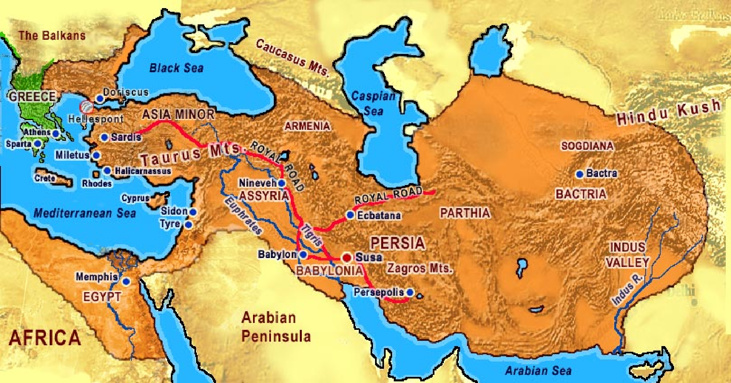

Chapter 1: Study Notes and Questions
*All notes are drawn from the New Interpreters Bible Commentary Volume III pages 855-892
Verses 1-4: There is probably some Hyperbole with this story – Feasting for 180 days (6months) with all of the government officials and all of the Persian Army – How did the Empire not collapse?
Verse 8: “Drinking… without restraint” NIV: (allowed to drink in his own way) – tradition was that when the king drank everyone was supposed to drink. That rule was suspended for this feast.
- Several times in this book the same Hebrew phrase is used meaning “special ruling” – this is to demonstrate that everything in the kings court was done according to the whims of the king.
Verse 9: Queen Vashti – “Vashti” comes from the Persian word for “Best” – Historically Xerxes queen was Amestris and she remained queen throughout his reign. (This is another clue that the book of Esther is story not a historical account).
Verse 10: The king is drunk – his actions are not quite rational – Vashti’s response is appropriate.
Verse 12: Why do you think that she refused to be summoned? This is unexplained.
Verses 10-22: There seems to be an over emphasis on respecting the law. This sets up the rest of the story where later the respect of the law will have greater consequences.
What are your thoughts about the decree of the king?

Chapter 2:
Verse 1: After these things… the king remembered Vashti – How did he remember her?
- Later translations read (remembered Vashti no longer) & (remembered Vashti with regret)
How do the actions of the “young men” respond to the feelings of the king?
Esther has two names: Hebrew: Hadassa meaning “myrtle” (plant) and a Persian name, Esther meaning “Star”. Esther in Hebrew means “I will hide”. It was common for Jews in the diaspora to have two names.
What are your thoughts on the process of finding a new Queen?
“The author here displays his knowledge of Near Eastern harem customs, well known from the later Ottoman Empire. Although the women of the harem were sequestered and dependent upon male favor, a woman could wield enormous power from within the walls of the palace, especially if she were the queen and/or the mother of the heir. Persian history is speckled with tales of harem intrigue; Xerxes himself was killed in a harem coup.” NIB Commentary – 889
Verses 15-18: Esther is taken to the king in the seventh year of his reign. Four years have passes since the downfall of Vashti.
- Vashti fell at a banquet; Esther completes her rise to power at a banquet.
Mordicai appears as a righteous man (supporting the king) without thought of reward. Both he and Esther are painted in a very favorable light in this story. These actions will be in contrast to Haman’s.

