Acts of the Apostles
Chapters 1 & 2
Read Acts 1:1-11
Discuss:
What does this passage say about Jesus?
What does this passage say about ascension?
We have heard of these “two men” before…
Luke 24:1-4 But on the first day of the week, at early dawn, they came to the tomb, taking the spices that they had prepared. ² They found the stone rolled away from the tomb, ³ but when they went in, they did not find the body. ⁴ While they were perplexed about this, suddenly two men in dazzling clothes stood beside them.

Read Acts 1:12-26
Discuss:
What do the disciples do after witnessing the ascension?
By what method do they choose another apostle?

Read Acts 2:1-13
Discuss:
Pentecost is a Jewish Holiday of harvest – what are the implications of the Holy Spirit coming on Pentecost?
Consider the Holy Spirit. Is the Spirit given to individuals or to a group?
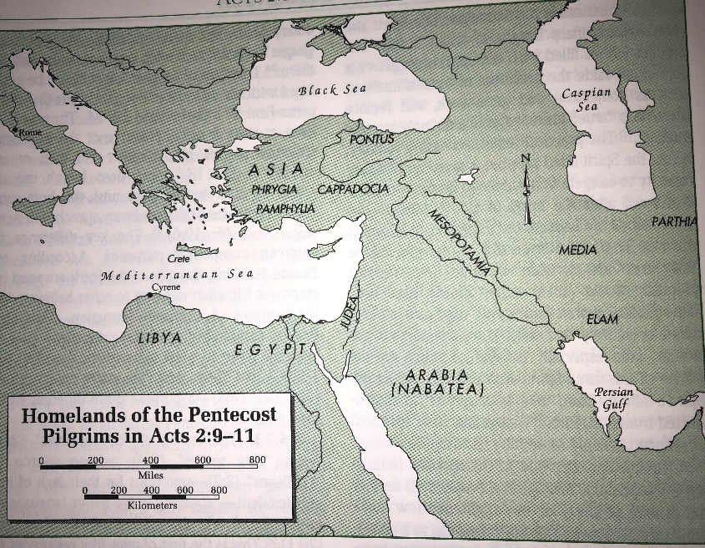
What are the “benefits” of the Spirit?
Look at the map to determine where each of these groups once lived.

“The list includes various “ancient” nations no longer in existence when Luke wrote Acts (e.g., Parthians, Elamites), and the Cretans or Arabians are better understood as groups rather than nations. But Luke knew all of this! The narrative function of the list is theological, defining the inclusive boundaries of the household of Israel for whom the promise of restoration is now going forth from the community of the Spirit. “ NIB, Vol. X pg 56

