1 Corinthians 7-16
1 Corinthians 7:1-40, Paul’s response to questions about relations in sociosexual groups
- 7:1-7, Husbands and Wives
- 7:8-9, Widowers and Widows
- 7:10-11, Married Believers and Divorce
- 7:12-16, Marriage Between Believers and Unbelievers
- 7:17-24, Indifferent Matters: Jew, Greek, Slave, Free
- 7:25-28, Counsel for Unmarried: Paul’s Own Maxim
- 7:29-35, A digression regarding life lived eschatologically
- 7:36-38, Betrothed Unmarried and the Idealized Responder
- 7:39-40, Divorce, Widowhood, and Remarriage

Read Chapter 7 – What surprised you?

Paul seems to be responding to the opening statement, that some of the Corinthians believed that Paul was advocating “It is good for a man not to have sexual relations with a woman”. Paul seeks to clear up this false belief.

According to what you read: How would you describe the relationship between husband and wife?

How does Paul deal with divorce?

“The New Testament shows a persistent commitment to restoring relationships, to affirming peace and reconciliation.”

According to this reading what is the purpose of marriage?
- Procreation
- An Acceptable Expression of Sexuality
- Companionship
- Love

How might this conversation on Sociosexual relations speak to our world today?

What is one thing that the group should know from this chapter?

1 Corinthians 8:1-11:1, Paul’s response to a Corinthian Question about eating idol meat
- 8:1-6, Their question, their assumption, Paul’s rehearsal of what they know
- 8:7-13, Persons Differ in Knowledge – An Imaginary and Instructive Scenario
- 9:1-10:13, Extended digression consisting of two examples
  - Paul as Exemplar
  - The Exodus retold as caution
- 10:14-22, Paul’s application: “Flee Idolatry”
- 10:23-11:1, A second summing up

What is one thing that surprised you in this section or what is a question you have?

See the attached map of Corinth. How many places of worship do you count?

What does idolatry look like in our world today?

“How does one honor and protect holiness, being set apart for God, while one lives in the world, in the midst of normal social exchanges that one encounters in Corinth?” How do you answer this question?

“Love builds up”(8:1). Love is Paul’s most important concept in describing how believers rightly relates to one another, and it is so critical to his corrective of the Corinthians’ interaction that he devotes a whole chapter to it (Chapter 13). Love is not just a sentiment, not just a feeling, not merely a sort of disposition. Love works; it acts; it does thing; and the chief thing it does is to edify, build up, cause growth in each of the persons who engages in it and who is engaged by it.

1 Corinthians 10:13 ¹³ No testing has overtaken you that is not common to everyone. God is faithful, and he will not let you be tested beyond your strength, but with the testing he will also provide the way out so that you may be able to endure it.

This verse is commonly used in times of crisis. One interesting note: All of the word’s for YOU are plural. Paul is speaking to a community. How does this information change the meaning of this passage?

The context of this verse is amid a paragraph about the Exodus. Paul tells the people that God is faithful and that God’s testing will not be too severe or God will provide a way out (an exodus) so that you can endure. How might the story of the exodus speak to our popular notions of testing?

Which verses are the most meaningful to you in this section?

What is one thing that the group should know from this section?

1 Corinthians 11:2-14:40, Three worship practices of the community
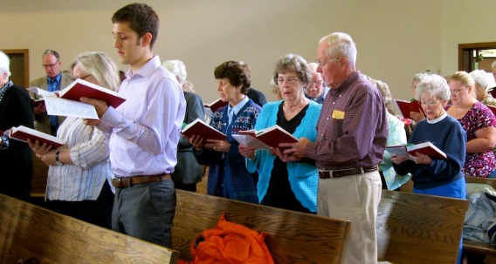
- 11:2-16, Proper conduct of women in worship
- 11:17-34, Not the Lord’s Supper
- 12:1-14:40, The proper function of Spiritual Gifts
  - Basics about the Spirit
  - Diversity and its significance
  - Body Metaphor with Baptismal tradition
  - Members proper interrelation within the body
  - An Oratory on Love
  - Paul’s affirmation of edification and practical suggestions

Read this section: What is one thing that surprised you about what Paul writes?
What is one question you have?
Paul expects women to cover their heads in worship – why?
Why do we not share the same expectation today?

What does 11:27 mean to you?
How can one eat and drink the Lord’s Supper in an unworthy manner? (What would be one example?)

In Paul’s view, the Lord’s Supper is the ideal place where proper self-assessment takes place. So to partake of the Lord’s Supper “worthily” is not to be confused with deserving or meriting God’s grace (an absurdity and an impossibility on its face), but it is participating the supper knowing that one stands only because of that grace and knowing just where one stands in one’s growth toward maturity. When one properly self-assesses, then that person can take part in the service worthily.
No one can say “Jesus is Lord” except by the Holy Spirit (12:3)- What does it mean for you to say Jesus is Lord?
Paul uses a different list of Spiritual Gifts in Romans 12:3-8 – if these lists are intended to be illustrative rather than exhaustive are there other gifts not on this list that are gifts of the Holy Spirit?
1 Cor. 13 is often read at weddings because Paul has recognized some fundamentals about love no matter how it is understood. But it would be a mistake to assume that Paul has in mind romantic love… The love of which Paul writes so eloquently is a love that does not originate in one individual and reach out to another. Rather the love celebrated in this text comes from God, claims us, and through us reaches out to others not simply to another person whom we wish for our spouse.
What instruction do you take from Paul’s discussion on Speaking in Tongues?
What do you make of 14:34-36? Does it fit? – Should we honor this instruction?

What is one thing you think the group should know from your reading of this section?
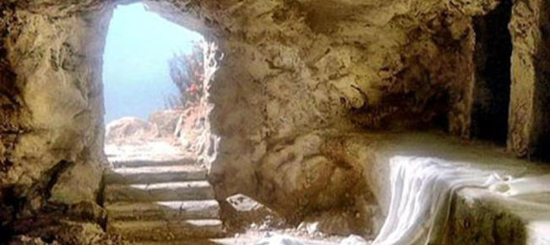
1 Corinthians 15:1-58, Discourse on Resurrection
- 15:1-2, Broad-Brush Scope of the Life of Faith
- 15:3-11, The Foundational Teaching
- 15:12-34, How Can Some Say There is No Resurrection of the Dead?
- 15:35-57, A fictional character allows Paul to write about continuity and change
- 15:58, Recapitulation

Read this chapter: What is one thing that surprised you about what Paul writes?
What is one question you have?
How would you summarize v12-34?

Paul looks forward to a future resurrection – Why might this emphasis be important in our world today?

Why would it be shameful for some people to have no knowledge of God (v34)?

“Sin as a power maneuvering to take advantage of us is one of Paul’s great insights. Paul has no truck with the common notion of sin as a wrong deed, as a particular action or set of actions that one should not do. Rather sin is a crafty power that tries to take control of one’s life and thereby entice one away from proper dependence upon God. Sin is a primary rival to God and to Christ regarding control over one’s life.” Thoughts? How does this notion influence Confession and Forgiveness?

In v35-57, Paul gives one of his most elaborate examples of the body in resurrection. What do you learn from this section?

Pay attention – who is acting (doing the work) in resurrection?

What is one thing you think the group should know from your reading of this chapter?

1 Corinthians 16:1-24, One more Corinthian Question, Paul’s Plans and Letter Closing
- 16:1-4, Response to a Query about the Collection
- 16:5-12, Projected visit plans and present purposes
- 16:13-18, Concluding Admonitions and Commendations
- 16:20-24, Final Greetings, Autograph, Concluding Grace

What is Paul’s instruction for the collection?
How much of our income is “extra”?

J.Paul Sampley, New Interpreters Bible Commentary, Volume 10, pg 792
Ibid 878
J.Paul Sampley, New Interpreters Bible Commentary, Volume 10, pg 792
Ibid 893
Ibid 898
J.Paul Sampley, New Interpreters Bible Commentary, Volume 10, pg 792
Ibid 938
Ibid 956
J.Paul Sampley, New Interpreters Bible Commentary, Volume 10, pg 792
Ibid 984
Ibid 792

